Dereham Alex Hill Memorial Tournament
27 April 2014
Tournament Report

Under 10 Boys
On Sunday 27th April the following players represented the Dragons Under 10s in the Alex Hill Tournament at Dereham, I was the Captain for the day.
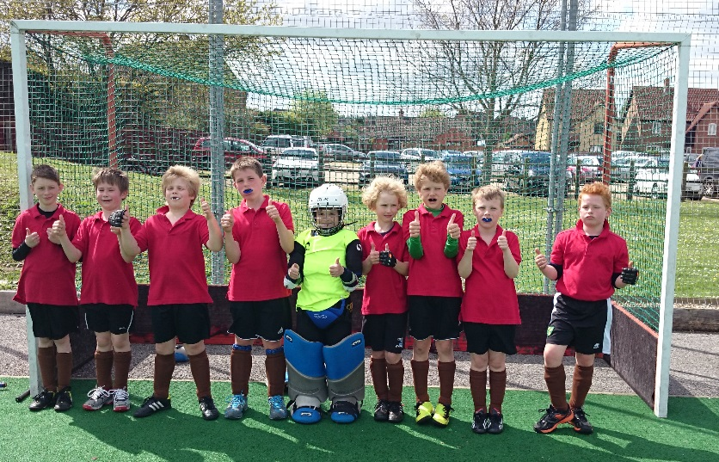
Manager: Natalie Beal
Assistant Manager: Christina Murgatroyd

Team:
Alex Brooks
Freddie Royall
Henry Greenfield (GK)
Ollie Hunt
Ollie Smith
Raphie Connors-Beckett
Sam Reynolds
Tommy Chambers (c)
Harry Fulller

The weather was lovely and the pitch great. We played four matches:
Pelicans - 3-0 win
In a high tempo start the first goal was scored by Freddie from my assist through the middle. This settled us down and the second was an excellent solo goal by Freddie. I scored the third thanks to Freddie assist and then some resolute defending and a good save by Henry preserved our three goal lead.

NCHC 'A' 0-2 loss
Without a break we then headed to play our toughest opposition of the day. We were forced deep for much of the match. Excellent defending from Raphie and Alex limited City to a few shots at goal. We conceded an excellent goal from Freddie Patterson but kept battling. We did create chances but to no reward and freddie was very unlucky not to get a penalty flick following great work when we were still only 1-0 down. City sealed it with about 5 to go.

NCHC 'B' 1-0 win
This was a tight game even though we seemed to dominate possession and territory. I made a good run and got pass in which was brilliantly finish by Harry. Despite sustained pressure the score remained 1-0. Freddie brought out a great save by their keeper late on but it finished 1-0. We then had a gap before the final game against Watton as we knew if we won we'd end the tournament as runners up.

Watton 2-1
I dribbled a long corner in which I then crossed and this was finished by a skilful touch by Harry. More pressure failed to bring reward before a Watton short corner had to be defended. Watton refused to give up as a tense period of play saw us holding on to our 1-0 lead. After a period of pressure Freddie gave us some relief with a 2nd after a goalmouth scramble. Against the run of play Watton pulled a goal back making for a tense last few moments but we held on.

We finished the tournament in second place and this was due to a great team performance. I was very proud to captain them and also to be given 'teammates player of the tournament'.

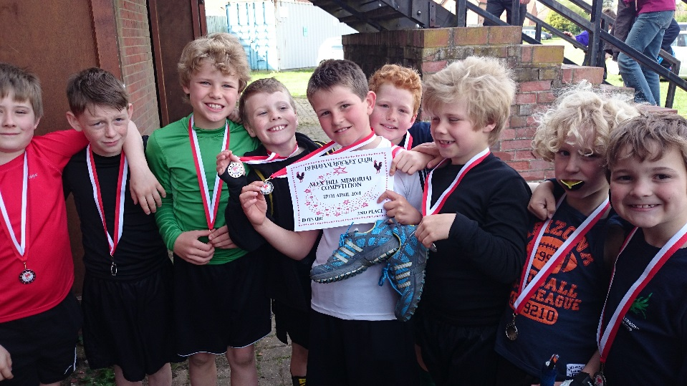

Thanks to Nat and Christina and all those that helped.
Tommy Chambers

Under 10 Girls B team
Manager: David Pentin
Assistant Manager: Katie Buxton
Amelia Marshall
Beatrice Harrison
Cody Poole
Isabelle Phillips
Kaitlin Wolmarans
Octavia Udy
Olivia Hendrie (Captain)
Olivia Tighe
Poppy Heeds (GK)

The first match was against the Magpies and the score was 0 -0. It was a tough midfield battle with few chances for either side.

The second match was against Watton and the score was 0 - 1. Octavia had a very good game in attack and managed to get the ball into the goal but unfortunately it was disallowed due to an earlier infringement.
The third match was against Norwich City A Team and the score was 2 -0. These were very strong opponents but the Dragon defenders did very well to hold the the score to just two goals.
The fourth match was against Dereham and the score was 0 - 0. Good early pressure created a few chances with a goal narrowly missed to both the left and the right but unfortunately goals. There was a great chance late on with our two Dragon forwards with their keeper but the ball hit the post.
The fifth match was against the Pelicans, the eventual tournament winners, and the score was
0 -6. Dragons struggled to keep up but Poppy Heeds managed to get lots of practice in goal!
The sixth match was against Norwich B Team and the score was 0 - 2. These was good early pressure but this unfortunately came to nothing. Finalised by one very last minute goal.
The seventh match was against the Dragons A Team, who came overall second, and the score was 0 -4. Please refer to A team report!

A few words from David…
A young Dragons Under 10 Girls B team which included several new players to tournament hockey did well at the Dereham tournament. The team played some good hockey and the results didn't reflect their performances and the team were unfortunate not to score a goal as they created good chances and had been the dominant team in several of their matches.

In goal Poppy Heeds saved a lot of shots using her pads and kicked the ball away well, thanks to the coaching Christina has given her. A strong defensive pairing was formed by Amelia Marshall and Isabelle Phillips in her first tournament who both tackled well and cleared the ball up field. Our two eight year olds Kaitlin Wolmarans and Octavia Tighe showed great skills with good passing and dribbling respectively. Cody Poole showed great endeavour and bravery bouncing back to play on after being hit on the upper leg with the ball winning the ball well. In attack captain Olivia Hendrie was linking well with forwards Octavia Udy for the first 2 matches before she moved to the A team to help with injury concerns and the Beatrice Harrison. Beatrice playing in her first tournament showed good dribbling forward with the ball and had several good efforts at goal.

Well done girls this display gives great encouragement for you as individuals and the Under 10 and 12 Girls teams next season.

Thanks to Katie Buxton for her help as assistant on the day and for the support and encouragement of the girls parents.

Enjoy your summer and look forward to seeing you all in September.

The under 10 girls…

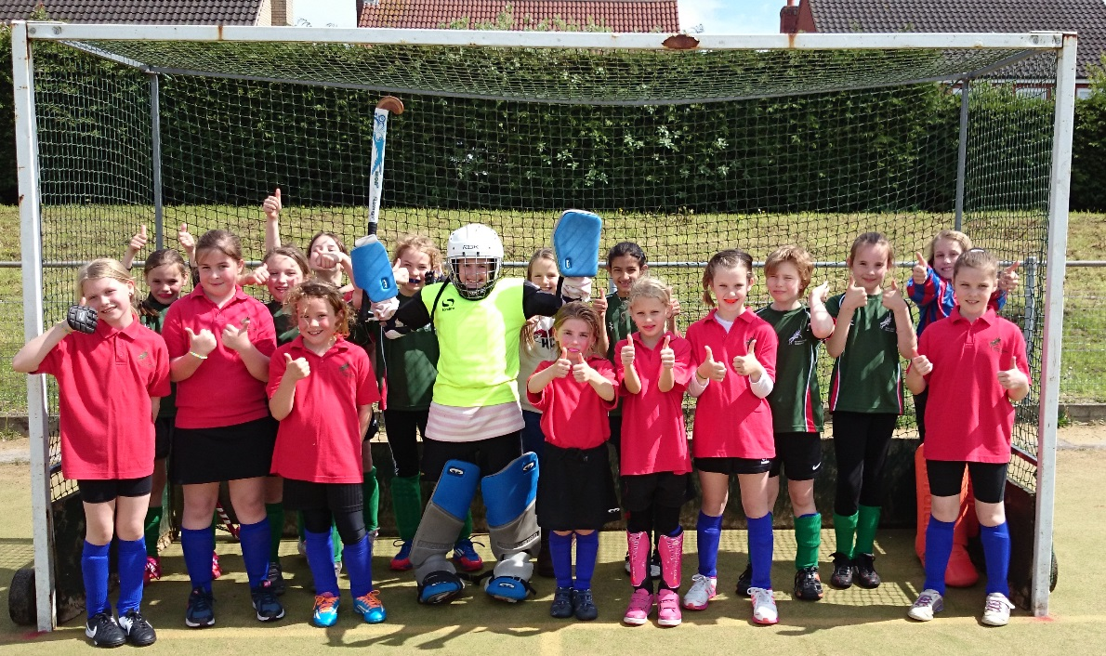

Under 10A girls
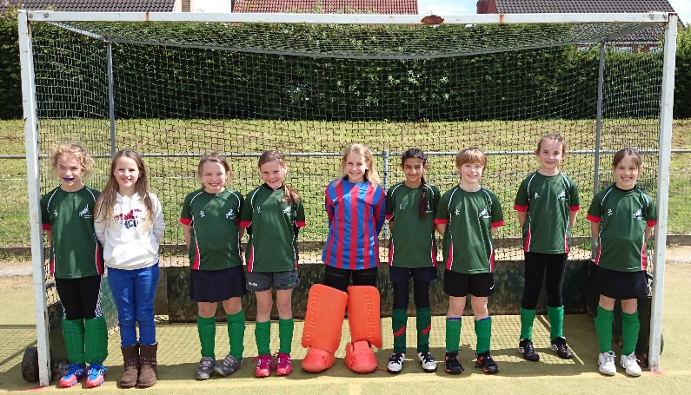
Manager: Natalie Beal
Assistant Manager: Jemima Easter (broken arm prevented play!)

Maddie Reynolds (recovering from a broken back!)
Amy Beadman
Mia Bailey
Piper Hempsall (captain)
Sasha Armstrong
Simran Rai
Stella W W
Tilly Connors Beckett(GK)
Octavia Udy (came over to the A team to help out!)

An exhausting 7 match tournament!

- match v Watton saw Tilly looking abandoned and lonely for the duration, three lovely goals from Maddie and a somewhat unfortunate own goal 4:0.
- Magpies ; Stella the superstar scored the only goal of the match 1:0
- Norwich City B team another fab shot from Maddie and second own goal of the tournament, ball passed from Amy, glancing off the opposition’s stick 2:0
- Pelicans; first tough match of the tournament, Dragons went two goals down on the new pitch, but heads kept high, took the game to the opposition again and again, keeping the pressure on, Maddie scoring first goal and the 2:2 draw sealed by Stella.
- Dereham; girls starting to tire after last tough match, short corner from opposition 1:0 down. Dragons lived up to their name, the fire never went out, stepped up the pressure, Simran and Piper foiling any attempts towards the goal, passing up to Amy, Sasha, Stella and on to Maddie, fantastic 3:1 win
- Norwich City A by now and exhausted bunch of girls conceded a goal early on. NC packed out their defending area and the girls just couldn’t get the ball past, 0:1
- Dragons B hats off to the B team who almost caught the A’s out early on in the game, but girls found last ounces of strength, Sasha and Octavia adding to Maddie’s two goals 4:0

Well done to the girls who finished second overall in the tournament. A lovely finish to the season, good luck to all the Y5’s moving up to U12’s in September.

Under 12 Boys
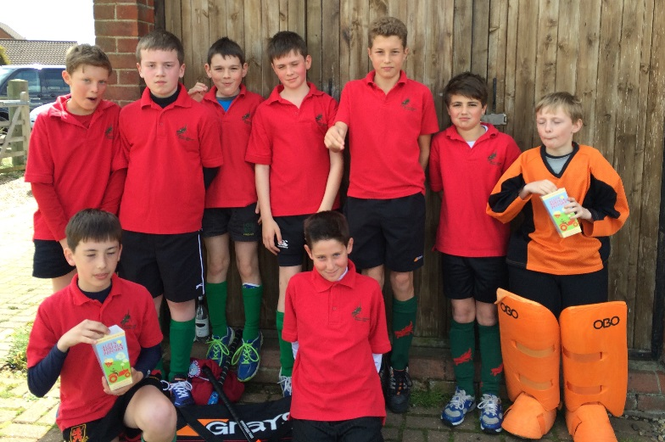
Manager: Laura Thompson Wright
Team:

Angus Blazer
Angus Cringle
Angus R E
Blue Hempsall
George Wright
Harry Brown
Harry Williams
Huck Hempsall
Joe Beadman

Short sharp tournament on a lovely sunny Sunday afternoon.

- Dereham: boys started well, early goal from team captain put boys in excellent spirits, attacking hard and taking the game to the opposition, a couple of unfortunate mistakes conceded two goals and unfortunately Harry’s goal disallowed 1:2

- Norwich City : Dragons up against a team with strong defensive strategy. The boys lost a short corner and two more goals and despite playing a strong attacking game just couldn’t get past the wall of yellow and green 0:3

- Pelicans tough match against a strong opposition team. Several opportunities to score blocked, a very fast moving opposition attack left the boys 0:2 down.

Some fantastic defensive play, especially George and Blue, but well done to the team, you never gave up! :)

Under 12A Girls Match Report
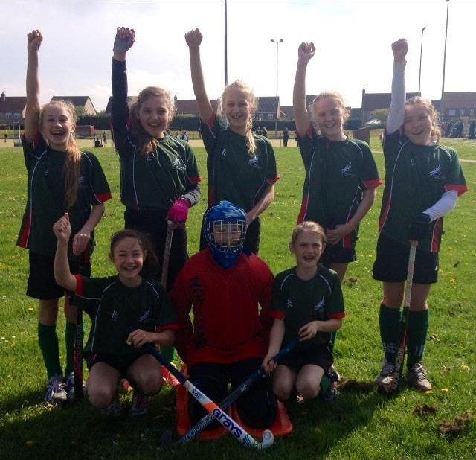
Manager: Gemma Rump
Team:
Harriet Marlee
Jodi Rump (captain)
Lara Taylor
Lucy Buxton
Meredith Winship
Molly Finegan (GK)
Scarlett Udy
Sofia Groves

Game 1: Dragons A Vs Dragons B – Won 5-0

In every tournament up until today, the girls have been slow to get going; however, todays saw an excellent start to the day, which meant that confidence was high going in to the subsequent game.

The teamwork was brilliant right from the start, with a pre-determined plan from push back between Jodi Rump and Meredith Winship working perfectly, and ensuring that the team pushed up the pitch to attack rather than playing their normal defensive game. Having concentrated well in the pre-match team talk, the whole pitch was used extremely well, with every player ensuring that they were always aware of the their position and thus everyone knew where they could pass the ball and that there would always be someone available to receive it, rather than everyone bunching along the middle of the pitch leaving great gaps of unused space.

Goal scorers: Lucy Buxton x 2, Jodi Rump x 2 and Harriet Marlee x 1

Game 2: Dragons A Vs Norwich City – Drew 0-0

An end to end evenly matched game that could have gone either way, with the final score of a draw being the fairest result. Again, the girls made good use of the pitch, and worked well together, although there perhaps wasn’t quite the same flow of the previous game as there were more interceptions from the opposition. This game involved the defence, including goal keeper Molly Finnegan, having to work hard to keep Norwich City from scoring, which they successfully managed to do. Similarly, the Norwich City defenders worked hard to keep our forwards from shooting. An even game, with the right result in the end, although a score draw would have been even nicer!

Game 3: Dragons A Vs Dereham – Won 1-0

The girls were a little tired in this game, and it showed, not in the final result, which came from a well struck ball by Harriet Marlee, but the movement wasn’t quite as determined, and the interceptions not as frequent as in the previous games. That said however, there were several good attempts at goal: with two shots from Jodi Rump, one from Meredith Winship, and two from Lucy Buxton. This goes to show how the score could have been on a different day…

Molly Finnegan, having not been troubled too much for the majority of the game, really came into her own at the end, remaining calm and confident under extreme pressure from a late Dereham onslaught! The buzzer could not have gone soon enough as Molly, with just two feet had an awful lot of sticks trying to get the ball past her and over the line!

Goal Scorer: Harriet Marlee

Game 4: Dragons A Vs Pelicans - Drew 1-1

The 14 minute break between the previous game and this one seemed to involve the eating of large quantities of popcorn amongst other foods, and it did the trick as the girls were back on form!

This was a good, well-paced and evenly matched game. Lara Taylor and Lucy Buxton defended very well, pushing the ball out to the side, making good use of the left and right mids and making it more difficult for the ball to come straight back into the D. Good solid passing and communication meant that the whole pitch was used well , and resulted in the goal being passed in from the right by Scarlett Udy, reaching Jodi Rump at the top of the D and with Meredith positioning herself well on the left allowing Jodi to avoid the defender with a pass to Meredith who scored a confident well struck goal.

Goal scorer: Meredith Winship

Game 5: Dragons A Vs Magpies – Lost 1-0

The score doesn’t really reflect the game as it could have gone either way; a draw would possibly have been a better reflection of the play. However, the girls should remain proud of themselves. The game was end to end, with some good positioning and movement in and around the D coming from centre forward Jodi Rump, and some good attacking runs from the three mids: Scarlett Udy/Harriet Marlee, Meredith Winship and Lucy Buxton. This game saw Sofia Groves back in defence making some good solid tackles, as well as Lara Taylor remaining in defence. The two defenders worked well with Molly, preventing the Magpies from having any good attempts on goal.

The goal could have come from either team, and it was just unfortunate that it wasn’t ours; however, credit to the Magpie girls, who worked as hard as the Dragons, and who eventually won the tournament.

Overall, today saw a great performance from every player. It was the last tournament for several of the girls who move up to development in September. It was lovely to see the goal drought ending so spectacularly – from 1 goal all season, to 7 in one morning!

Well done girls, it’s been a pleasure to coach and manage you for the last couple of years and I’m proud of how far each and every one of you has progressed so far.

Under 12 Girls B Team

Manager: Robert Coyle
Team:
Annabelle Hodgson
Charlotte Carr
Charlotte Knight
Jemima Easter
Jennifer Cox Kersley
Lilly Steward
Rebekah Young

