**9th March Tournament Reports.**

**County Championships at King’s Lynn**

* Under 10 Girls

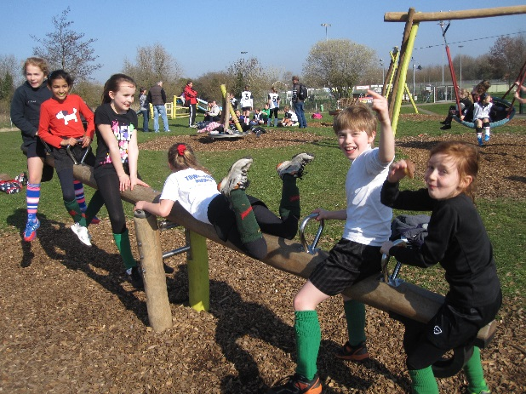 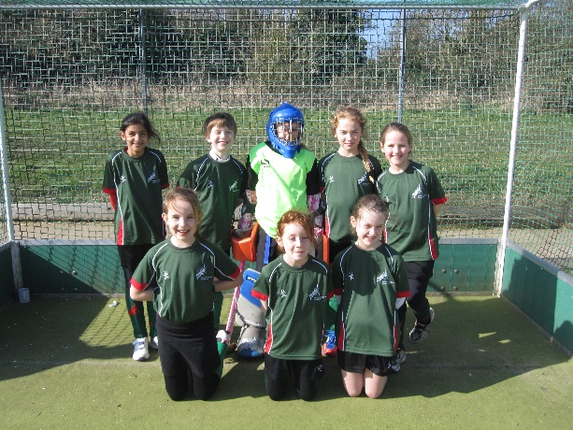

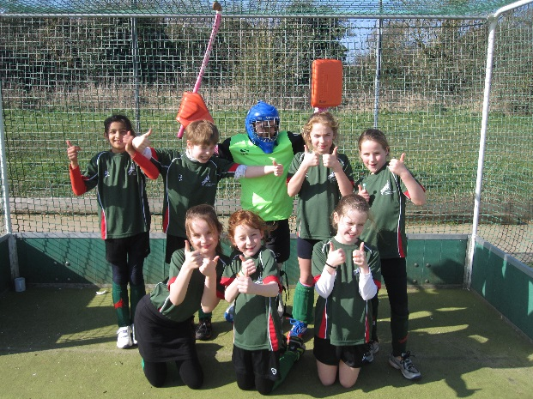

Manager: Natalie Beal

Jemima Watson  
Stella Windsor Waite  
Simran Rai  
Sasha Armstrong  
Mia Bailey  
Olivia Hendrie

Poppy Heeds (GK)

Maddie Reynolds

1st match vs Pelicans; 1-2

This was an outstanding performance but they scored first, then Maddy scored with a long shot, then they scored again. We played really well.

2nd match vs Norwich; 1-2

We went behind again but then scored with another long shot but they scored again. Coach Nats said we should try and score first next time!

3rd match vs Magpies; 0-2

This time they scored twice and then we scored but it was disallowed. They had beaten Norwich 4 nil so we did really well in getting so close. Nats said our goal should have been allowed as it hit the back board.

Jemima played really well and was player of the tournament. Stella played well too as did Simran.

Over all we came fourth but I think we should have come first!

Written by Maddy Reynolds.

Nats’ note: On another day, the girls could have come first! They dominated possession and territory in all the matches and had plenty of chances. I would say the girls just did not have the luck!

* Under 12 Girls

Manager: Gemma Rump

Molly Finnegan (GK & Capt)

Jodi Rump

Alice Martin

Lara Taylor

Esme Potter

Harriet Marlee

Lucy Buxton

Our first match was against **Pelicans**. We played very energetically and we ran for the ball and didn’t wait for the ball to come to us and because of that we got into the attacking D quite often. Even though we got close and had a few shots at the goal we didn’t score but thankfully Pelicans didn’t score against us either, which made the score 0-0.

After a break we played **Magpies**, we got into space very quickly and we passed the ball right into their D thanks to our mid fielders (Alice, Lucy, Harriet and Jodi). Even though we played very well we always seemed to be giving out short corners which gave them a strong chance to shoot. So once the whistle blew the score was 3-0 to Magpies.

Next we played **Norwich city**, we gave out 2 short corners but thankfully they were all saved by Lara who ran out and got the ball before they could shoot. Even though in the end Norwich city won the tournament we only lost 1-0 to them (thanks to our defence Esme and Lara who doesn’t normally play defence).

Lastly we played **Dereham**, at this point we were very tired and we weren’t running about as much as we had in the other games. We played very well even though we were tired and Dereham were very vicious with the ball. We didn’t get a chance to have a shot at goal and right at the end they scored which left the scores 1-0 to them.

By Molly Finegan

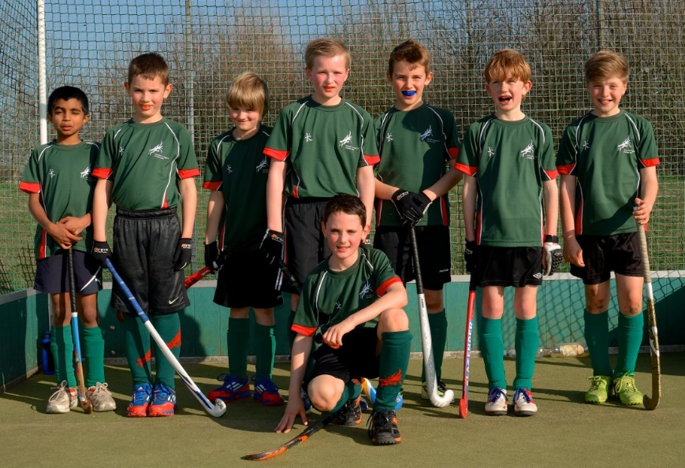

* U10 boys

Manager: Crossy, Rob Panter and Owain Diver Hall

Alex Wolfe (GK)

James Cross

Edward Cross

Arjuna P

Ben Panter

Casper Lind

Isaac Diver Hall

William Bowman

Cameron Tasker (captain)

Everyone who was here at the County Tournament last year will have vivid and unpleasant memories of the excruciatingly cold conditions. How different it was a year later – with glorious sunshine all day and a climate more like a May bank holiday. A perfect setting for our U10s to impress, with a team that has played together a lot and are a strong, talented side when they link up and play a team game.

**v Pelicans**

Pelicans can be an aggressive and useful side, but Dragons got off to a flying start with some super passing and movement and showed just how straightforward it can be when they stick to manager Crossy’s advice, which is to “let the ball do the work”.

Goals came easily as Dragons moved the ball about and used the whole width of the pitch. The first was a softie, dribbling over the line from Ben, which probably should have been saved and cleared. But the second came from a well-worked move involving James, controlling the centre of the pitch with his great skills and high work rate, who ran a ball into the D and unselfishly pushed it to Ben, who helped it into the corner.

James made the third by getting a good pass to Cameron, who was unmarked in space. Cam took it first time and played one of his signature big sweep shots, with the ball hitting the back board with a satisfying bang. Isaac scored the fourth after a strong build up of Greens attackers in the D and pushed into the corner. It was nearly five when three Dragons each could have had a go at a cross, though only one did, and diverted it just wide. But number five came quickly after with a rocket of a pass upfield from Cam, who found Isaac again – who coolly ran onto it and made sure.

Pelicans weren’t able to get into the game. They had one scoring chance in which they caught the backs napping in the afternoon sunshine, but their shot went wide. After that Dragons finished off with a sixth goal when William came on for Cam at left mid and switched it over cleverly to Isaac who pushed into the corner confidently for his hat-trick.

A text-book start for the Greens in their splendid new shirts, helping them to get a rhythm going and work on their linking up together. Pelicans may have been down one or two players and have been stronger in previous encounters, but this was good hockey from the Dragons and straightaway bolstered their goal difference, which is so often a decisive factor in these tournaments.

WIN 6-0

**v Magpies**

This season, Magpies have proved to be a strong and stubborn defending team, but less decisive in attack. The result has been a number of stalemates when it’s proved impossible to break down their back line. Much the same happened today.

Much of the first part of the game was tied up in the middle, with few shots on goal. A little bit of edginess crept into our game which showed up as we snatched our shots and passes, though Edddie and Arjuna at the back stayed cool, and did great service throughout. Eddie in particular has come on a lot this season and you have to be impressed by the calm way he deals with attackers – definitely a player to watch in the future. Arjuna too looks very assured – just what you want from your backs.

Pressure on the Magpies’ D started to show in the second half of the game with the forcing of both long and short corners, and with shots on goal that went just wide. James and Cam put in shots that only just went wide or took a deflection wide – Dragons needed their goal, one would do, to avoid the loss of points for a draw, and pushed hard on the solid Magpies defence. Finally the pressure told on the Whites as an ice-cool interception by Eddie was complemented by a lovely pass upfield on the right wing to Isaac, who crossed intelligently for Caspar to just help the ball into the goal. It came just in time for the bell and was a more than justified result for Dragons, who held most of the possession throughout the game but just couldn’t find an easy way through some determined defending.

WIN 1-0

**v Norwich City**

City and Dragons have been well matched this season, as they were last. These are always needling encounters, with neither side taking a loss well, and usually one goal is the difference, and that win or loss can decide the tournament. Unusually, City ran right through us last Sunday at The Den and we had to do a bit of work to make sure we weren’t telegraphing our tackles too fast, incisive players like Jonty B or giving able strikers like Freddie P too much space to compose their shots.

This was a much closer game and truer to form. City scored first when Dragons did exactly what they shouldn’t have been doing – by giving Freddie P bags of space to wind up a shot on goal. He didn’t connect with it properly but somehow it crossed the line. A defensive mistake by Greens who bafflingly decided not to tackle and a disappointing start to a match we needed to at least get a draw from, to go through.

A tough battle ensued. A full mention in dispatches goes to Will, who rushed out on a short corner to dispossess the City striker before he could compose a shot. James carried on with his usual incisive runs in the centre and only just managed to connect foot to ball after a great run into the opponents’ D. His energy was boundless notwithstanding the surprising heat of the afternoon and at times he was covering the whole width of the pitch in his determination not to relinquish possession. We had to defend a couple more short corners with locked sticks. Cam defended our left wing solidly from speculative advances by Jonty B, and was determined not to be suckered by his clever flicks over the block tackle.

Dragons’ determination paid rewards. Caspar got a good ball across to James who drew the defenders and unselfishly moved the ball out to Ben, who pushed it home to equalise. A really good, well-worked goal that amply demonstrated the merits of playing as a team rather than as a group of able individuals. That’s how it stood at the bell and was a fair result, with both teams playing good hockey.

DRAW 1-1

**v Dereham**

The days when Dereham was a soft match and an easy win seem to have abruptly ended. There has been a renaissance in the Dereham U10s – which may be no bad thing for the Norwich sides, who may now have to think about something else than how to score points each other.

City had already lost to Dereham this afternoon. This meant Dragons needed a draw at least if the vicissitudes of goal difference were not to be a factor in deciding the two qualifiers.

Dereham created the early pressure in an otherwise even encounter – until Robbie W broke through for the Reds and kept possession of the ball long enough to score a very decent-looking goal, putting his side one up. Our mids battled away and started to make inroads into the Reds defence. Caspar, James and Cameron worked hard to get an advantage but couldn’t make the decisive play. Our first proper scoring chance came from a super passage of play beginning with a strong run from Ben who put in a strong shot. It deflected back out again from the boot of the goalkeeper to Cam, who went down low for another of his hammer-blow sweep shots, which only just crept wide.

Dragons had a lot of the possession in the second half of the game but just couldn’t score. Dereham were very composed and always looked dangerous in the break. Their short corners came out hard and fast and again Will was there to smother their shots – a very brave performance from him. But a rare prevarication in our defence getting our ball away from our own D was enough to let Robbie W in to steal the second goal.

Right on the bell Eddie did a great run down the right wing to set up a lovely cross to Cam in the centre. Cam decided to tear the goal netting with the ball and fired an Exocet – but drove it wide! A miss in the adult game which would have cost him an expensive round at the bar; though it didn’t make a difference to the overall outcome – which was now down to the all-important goal difference.

LOSS 0-2

Dereham went through to the next stage on the strength of four good wins. Dragons and City finished on equal points based on W2, D1, L1. But those six goals against Pellies ended up being pivotal to the outcome. Dragons were runners-up thanks to them and also progress to the next stage, a terrific result for them after the disappointment of third last year. This was some of the best hockey we’ve seen from this young side and it bodes well for them for the remainder of the season and next year. Well done to all of them and to coaches Crossy and Panter for all their hard work that got us here.

By Cameron Tasker (or his Dad!)

* U12 boys



Manager: Ali Smyth

Angus RE (GK)

George Wright

Jono CB

Tom Bailey

Raunaq Rai

Edward Taylor

Ollie Shippam

Dani L M

Harry Williams (captain)

Dan Murphy

Today Norwich Dragons u12 boys took part in the County Championship at Kings Lynn. Our first game was against Pelica

The boys got off to a good start with an early goal from Dani Long- Martinez. Dani then followed this up with another two goals in quick succession, which completed his hatrick. With some great defending we kept Pelicans from scoring. **Final score 3-0 to Dragons.** Man of the match was Dani Long-Martinez with his three goals.

Our next opponent was Norwich City and we knew this would be a tough game. We were a bit vulnerable at the start and gave them a few chances but with some good saves and defending we managed to hold them off. Once we got going we were passing the ball well and created some good opportunities to score but the opposing keeper made some good saves. Luckily a ball was crossed into the ‘D’ and Jono managed to get on the back post to finish it off. From then on we dominated the match with lots of strong shots, but the final score remained as **1-0 to Dragons**. MoM was the team for an overall strong performance.

Our final game was against Magpies and we knew we needed a win to be certain of first place. Magpies put us under a lot of pressure from the start but with some excellent saves from Angus we managed to stay in the game. Once we got possession of the ball we always looked like scoring but we couldn’t get the final shot away, which kept the end result to a **0-0 draw.** Man of the match was Angus with some great saves keeping us in the game.

Fortunately for us Norwich City drew their final game 1-1 to Pelicans, which guaranteed us 1st place and a position in the Regional finals.

By Harry Williams

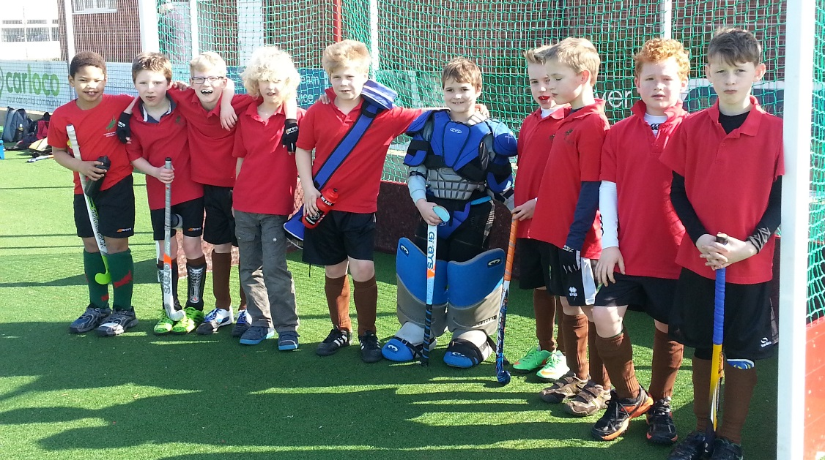

**U10 boys Taverham**

Manager: Spike

Henry Greenfield (GK)

Sam Reynolds

Freddie Royall

Oliver Hunt (captain)

Raphie CB

Sam Archer

Jack Foulgar,

Harvey Nkrumah

Adam Jones

Bertie Pinching

Thank you to Norwich City for stepping in to host a mini match for Dragons this Sunday.

There were 3 teams in total, Dragons, Norwich and a mixed team of Dragons & Norwich.

We had 6 matches in total…

We had two really good matches, our 4th match against city where we won 2-0 (both goals scored by Freddie) we didn’t have anyone in goal for this game. Also our 6th game where we won 3-0 against the mixed team.

On the other games Henry made some great saves and we scored many goals!

Freddie and Sam A were on fire scoring goals. Harvey and Raphie did some great passing down and defending.

Adam worked hard and covered plenty of ground while Sam R was on the ball making some great passes along with Bertie and Jack.

There wasn’t an overall winner because we were in and out of the mixed team but I am sure Norwich City wished they could steal a few of our players!

Thank you Spike for managing us on this unusually hot sunny day. A lovely day for spectators, hot work for us players.

Great work team.

By Oliver Hunt.

**U12 boys Taverham**

Manager: Steve Linford

Joe Beadman (captain)

Harry Brown

Aiden Buttles

Angus Cringle

Gus Sanders

Another outfield player borrowed from one of the other teams

A goalkeeper borrowed from one of the other teams

Match 1 : Dragons v Norwich City [Final Score 1 - 2]

All of the early pressure came from Norwich City and weak defending saw them score an easy goal. In their next attack, City scored again and the question was how would Dragons respond?

The answer was that their heads did not drop and they fought back well. Angus made a strong and determined run at the City back line but could not quite find the net. Then, Dragons won the first short corner of the match; Joe fired it to the edge of the D, but the shot went just wide.

However, City then had a spell of pressure, but good defending from Gus and Joe kept them at bay.

Dragons then scored! Angus attacked and, although he shot from just outside the D, it took a deflection and went in. Dragons then had an opportunity to equalise when Aiden fired a strong pass into the D from the right-wing, but no-one could get onto the end of it.

The whistle blew for the end of the match. Dragons had lost 2 - 1, but had done well, considering they had not played together before and had had to borrow a goalkeeper and an outfield player.

Match 2 : Dragons v Dereham [Final Score 1 - 0]

Dragons started this game very much on the front foot. Harry gained an early corner and Angus made another good run, but pushed his shot just wide. Dragons won the first short corner of the game; Joe fizzed it to the edge of the D, but Dragons couldn't get a shot away. Then Aiden put in another good cross from the right, but a Dragons player could not tuck it away.

Dereham had a good spell of pressure with a good cross/shot that ran across the face of goal and a corner.

However, with the game drawing to a close, it was Dragons on top. First, a short corner and then a corner; Joe took it and pushed the ball across the D and there was Aiden to score. Then Harry crossed accurately from the right, but Aiden was unable to knock the ball in from a yard or so out.

The game ended 1 - 0 to Dragons, but 2 - 0 would not have flattered them.

Match 3 : Dragons v Magpies [Final Score 1 - 3]

The game started with a good early run from Harry, but Magpies attacked strongly and scored the opening goal of the game.

However, Dragons equalised with the goal of the game. Harry made a determined run down the right-wing, pushed the ball across the goal and Joe was there to flick the ball high into the net with real venom!

From that point in the game though, Magpies were able to gain the upper hand. Gus and Joe tackled hard in defence, but Magpies scored two goals in quick succession. Dragons were starting to look a bit tired at this stage, but Gus continued to defend manfully. It was all Magpies as the clock ticked down, but they could not find a way through the massed Dragons defence.

The game finished 3 - 1 to Magpies.