MATCH REPORTS - 2 MARCH 2014 TOURNAMENT

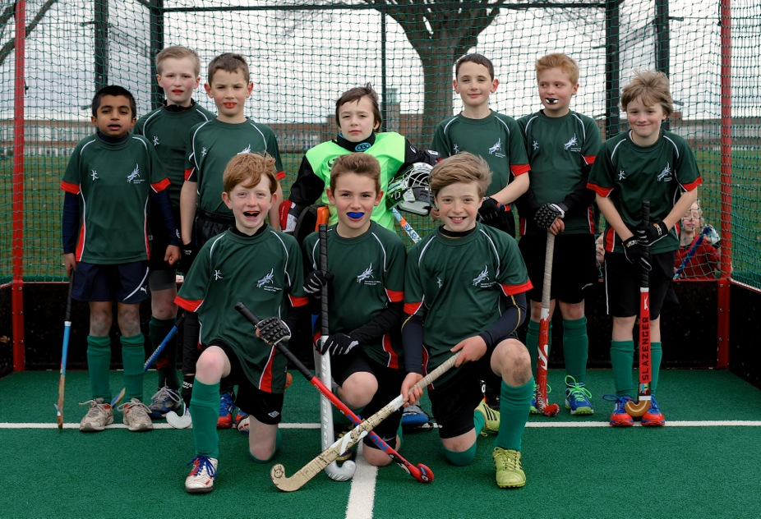
U10 Boys Geen – Gold Tournament
Manager – Rob Panter and Crossy
James Cross (captain)
Alex Wolfe (GK)
Arjuna
Ben Panter
Isaac Diver Hall
Cameron Tasker
Casper Lind
Edward Cross
Jake Reynolds
William Bowman

First game – a very one sided 0-0 draw, the ball hit both posts & evaded several sticks with goal at our mercy, both Cameron and James put in good crosses that we failed to convert, Pelicans got a let off.

2nd Game – again the team dominated and this time thanks to determined work by Jake Reynolds we managed to score and win the game v Magpies 1-0.

3rd game – after previous results we knew a win was required, sadly we were undone by a more clinical City team who were able to take their chances. The boys worked hard but were unable to create too much up front. Two All in Tournaments with City with 2 to go……!

U10 Boys Brown - Silver Tournament
The Team
Sam Reynolds
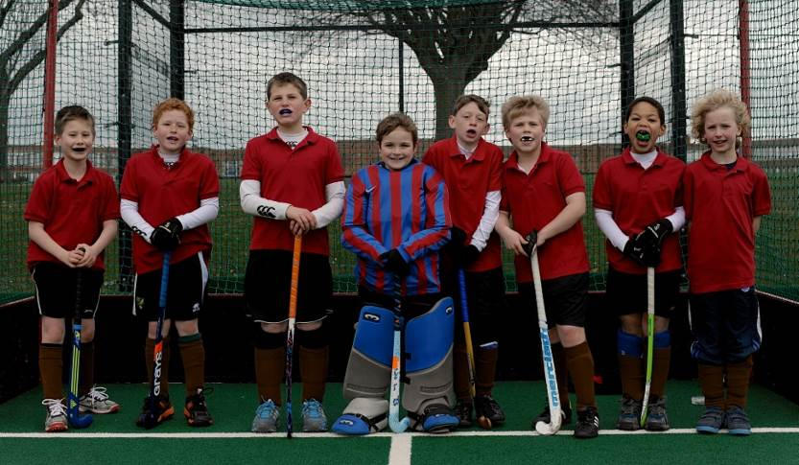
Harvey Nkrumah
Henry Greenfield (GK)
Raphie Connors Beckett
Tommy Chambers
Freddie Royall (Captain)
Oliver Smith
Bertie Pinching
Oliver Hunt

Manager
Owain Diver Hall

Match 1 v Norwich City 0-2 L
Match 2 v Dragon C 1-0 W
Match 3 v Dereham A 0-1 L

Match 1
Despite good defending by Sam Reynolds and Harvey Nkrumah, Dragons lost to a strong Norwich City Team. The team kept trying to the very end.

Match 2
Dragons B came up against Dragons C in the second game. Tommy Chambers and Freddie Royall linking well to open up the opposition with Freddie scoring. Good passing and tackling all round.

Match 3
The last match was against Dereham A and Dragons were unlucky not to score. Dereham scraped through by a single goal. Particularly well played to Raphie CB and Henry Greenfield in goal.

Well played to everyone involved, there were good performances across the team and everyone left looking forward to the next match.

By Freddie Royall

Under 10 Boys White – Silver tournament.

Jack Foulger
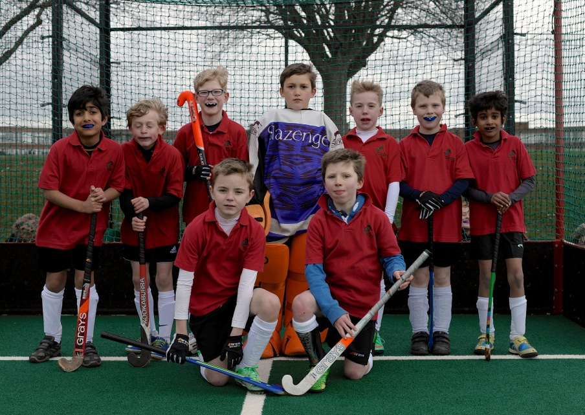
Sam Archer
Rahul Kaushal
Harry Fuller
Jonny Taylor
Adam Jones
William Utting (captain)
Monty Patel
William Waller (GK)

“The Dragon White U10 Boys showed commitment and dedication throughout every game played. For many of them it was their first every hockey game. Whilst playing and losing against Dereham, Dragons Brown and Norwich City B teams their improvement in defence and attack was outstanding, which was proven by their first goal. Well done to all in Dragons White U10 Boys”.

Under 10 Girls green - gold tournament
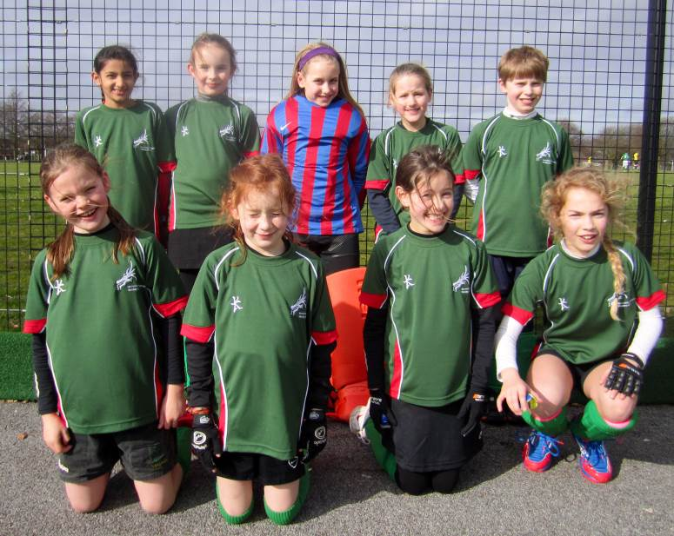
Squad: Sasha Armstrong
Mia Bailey
Amy Beadman (captain)
Tilly Connors Beckett (goal keeper)
Piper Hempsall
Simran Rai
Maddie Reynolds
Jemima Watson
Stella Windsor Waite

Manager: Natalie Beal

Match 1 : Green Dragons v Norwich City A [Final Score 0 - 0]

Green Dragons started the match off well with some good early pressure. City began to fight their way back into the game and in their first serious attack, there was some good defensive play from Jemima.

The first short corner of the game was awarded to Green Dragons and it resulted in Maddie just firing wide. City then won a short corner, which they, in turn, fired wide.

The clock was ticking and despite some very good late pressure from the Green Dragons, the game finished 0 - 0. Overall, Green Dragons had the best of the game, but just could not find the back of the net.

Match 2 : Green Dragons v Dereham [Final Score 5 - 0]

Green Dragons began the game on the front foot with Maddie scoring an excellent individual goal in the first minute of the match. A second was soon to follow with Amy scoring from the right-hand side of the D.

Dragons continued to press forward and Maddie was unlucky after a strong individual run, with her shot just going wide of the far post.

However, Green Dragons continued to pour forward and further goals soon followed. Stella scored the third, Maddie the fourth and Mia the fifth.

The end of the game was approaching, but it was still Dragons going forward and winning a short corner. However, they were unable to convert it into a goal and the final score remained at 5 - 0. This was a dominating performance by Green Dragons.

Match 3 : Green Dragons v Pelicans [Final Score 0 - 0]

Pelicans mounted the first attack after the whistle had blown to start the match. However, Green Dragons repelled their thrust and in their first attack, Maddie hit the outside of the goal.

Pelicans attacked again, but Simran was strong in defence and made an excellent pass to Maddie, who was able to launch another attack. Dragons pressed hard, winning three short corners in quick succession. Amy had a shot on target saved by their goalkeeper, but still a goal would not come.

Pelicans began to exert some pressure upon Dragons, but Stella and Piper were putting in some determined tackling in midfield. Suddenly, Pelicans broke away and it looked as though the deadlock was going to be broken, but their shot hit the outside of the post!

There was further good work in defence from Jemima and Simran. The end of the game was approaching and Dragons were trying hard to win it. A short corner was gained, but a goal would not come and the game finished 0 - 0. Although Pelicans hit the post, on the balance of play, Green Dragons looked the stronger side.

Match 4 : Green Dragons v Magpies [Final Score 0 - 1]

This match looked as though it was going to be a tough test for the Green Dragons. Magpies started strongly and it needed good tackling and chasing from, in particular, Mia and Simran to keep them at bay.

The first short corner of the match went to Magpies and it needed a stop from goalkeeper Tilly and a powerful clearance from Jemima to avert the danger. Dragons though were also a threat and from their first short corner, a good save was required from a shot by Maddie.

Magpies, however, were not to be denied and scored the only goal of the game. Although Dragons continued to press forward, with good work from Piper and Sasha, and with Maddie continuing to be a threat, the equalizer would not come. The game finished 1 - 0 to Magpies.

Magpies were the eventual winners of the Girls Under 10 Tournament, so to lose 1 - 0 was no disgrace.

Player of the tournament was Maddie Reynolds.

Under 10 Girls Red - silver tournament

Manager – David Pentin
Poppy Heeds (GK)
Fleur Barton
Lucy Curtis (captain)
Kaitlin Wolmarans
Amelia Marshall
Ashlyn Gibb
Olivia Hendrie
Zarina Duffield

For the first time, Dragons were able to enter two under 10 girls teams into a tournament. Despite the girls having never played together before but they were all raring to go and full of energy.

The team played Magpies B, Norwich City B and Watton and although they lost all matches the girls continued to battle and did not let the defeats affect their attitude. All girls played hard and enjoyed themselves but particular mention must go to Poppy in goal who was tenacious and saved multiple attempts on goal.

David Pentin as usual was excellent in organisng all the girls and keeping them up to speed with what was going on.

All the girls particularly enjoyed the cakes and tuck shop.

Under 12 Girls Green - gold tournament

Manager: Gemma Rump
Molly Finegan (GK)
Alice Martin
Aspen Gilvey
Esme Potter
Jodi Rump
Lara Taylor (captain)
Logan Gilvey
Lucy Buxton

Match 1. Norwich City 1 Green Dragons 0
The first match was against Norwich City A . Unfortunately it was a slow start and we came under pressure early on. However, Molly made some great saves and Esme and Logan were really good in defence. We were unlucky to lose the match 1-0. We seemed to bunch up in defence and need more attacking play. To work on: more accurate passing and pushing up the pitch a bit more to score.

Match 2. Magpies 1 – Green Dragons 0
This match started with a much more positive attitude. We had much better passing and were using the sides of the pitch much more effectively. It was really unlucky that Magpies scored early on. Aspen was great in midfield. Overall, I think that (again) we were unlucky to lose the game and this game really showed that the Dragons were working much better together, playing like a well-established team. To work on: better and closer marking of the opposition!

Match 3. Dereham 0 – Green Dragons 0
In this match against Dereham, we had a much more attacking start! Lara had a good shot on target and Alice was really good at tackling, taking corners and getting into good spaces. Molly made some GREAT saves. Aspen also did really well trying to get the ball up the pitch. Esme made some really good tackles and effectively hit them up the pitch but unfortunately we just could not get round to putting them in the goal. We had 3 good shots on target and were very unlucky not to win. Overall, outstanding effort and play! To work on: finishing and getting the ball in the goal!

Match 4. Pelicans 3- Green Dragons 0.
This was by far our fastest start. We played well from the outset. Excellent defending by Logan. Jodi played really well in mid-field with solid tacking and close marking. The second goal by Peilicans was very unlucky. It was great To work on: we need to help the defenders by getting into more spaces for the hit outs.

Overall summary
Player of the tournament: Molly for fantastic saves using both feet and hand!
To be honest it is a massive improvement from last time and a great team effort, amazing play by everyone well done !!!!

U12 girls pink dragons – Silver Tournament.

Manager: Amelia Dawson and Robert Coyle
Sofia Groves (captain)
Alice Young
Annabelle Hodgson
Harriet Marlee
Jennifer Cox Kersley
Lucy Cox
Nicky Dawson
Yllandah Brown

The Pink Dragon’s came together for Sunday’s tournament as a team which is gaining both in confidence and ability. Their first opponents were Norwich City who dominated early on and gave Dragons little opportunity to get a foot in the scoring. The final score 5-0 led the girls to make some changes on the pitch after conferring with manager Rob. The game against Magpies showed that this small change was effective and was seen in Annabel’s good defending, the girls played a tighter game pushing into the Magpies half. However this did not materialise into goals with the final score 0-1. Their next match was against the Pelicans who took possession early on and several attempts on goal were thwarted by Sofia making brave attempts to leave the goal line and clear the ball. Dragons made attempts on goal with Lucy Buxton taking the ball all the way up the pitch to the Pelicans goal, to find no way in. Pelicans finally scored to sneak a 1-0 win. The Dragon’s final match was against Dereham where there was recognition of the need to pass and support, leading to a much better game for the Dragons. Sofia shouting support and instructions demonstrating that more of the game was played more in the Dereham half than the Dragon half. More attempts to score did not lead to goals for Dragons and Dereham were lucky to sneak a goal past the team and into Dragons Goal.
Overall the team played well together although they need to remember to spread out, tackle earlier and convert their attempts to GOALS!!

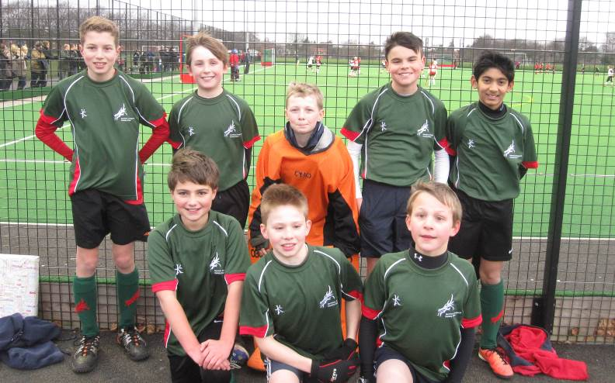
Under 12 Boys Green – Gold Tournament.

Manager: Natalie Beal
Angus RE (GK)
George Wright (washing shirts)
Jono CB
Ranauq Rai (captain)
Ollie Shippam
Harry Williams
Daniel Murphy
Dani L M
We played lots of good hockey with our formation: 2-3-1. It was good exercise and everyone had fun.

Won 1-0
Our first game was against Pelicans who all had hard hits but we coped well. They had a great goalie which made it harder. Our goal came from Ollie who hit it into the corner. Dani was man of the match with his great tackles and attacking moves.

0-0
Our second game was against Norwich who were a very strong side. We saw that their great forward had a big wind up when he shot so we jabbed and took the ball off him. This was a very tight game and we managed to come away with a draw. Man of the match was Angus R-E because of his great saves.

Won 2-0
Our third game was against Magpies B. We dominated this game. Our first was by Raunaq who hit it into the corner and second was also by Raunaq who skilled the keeper. Man of the match was Jono for great attacking play.

Won 0-0
Our fourth game was against Magpies A again. This was a tense match because if we won this game we would win over all because Norwich drew against Pelicans. This was a close, tiring game. Unfortunately we came away with a draw and Norwich won with goal difference.

Well done all!!
Report by Raunaq Rai

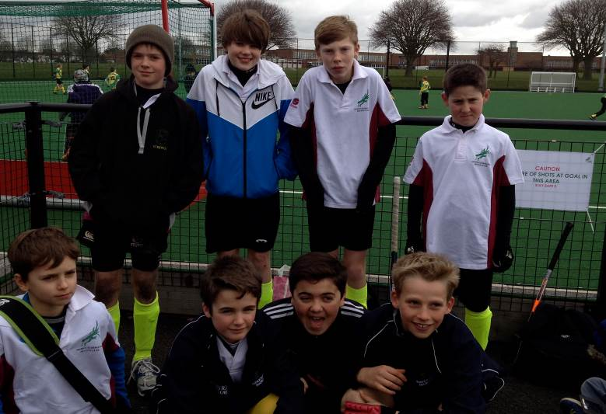
Under 12 boys White – Silver tournament

Manager: Steve Linford
Ezra Kahn (GK)
Tom Bailey
Edward Taylor
Huck Hempsall (captain)
Angus Blazer
Harry Smith
Tom Linford (washing shirts)
Leo Sargent

Despite their parents being chilled to the bone on a blustery Sunday, the Dragons’ B team left with smiles on their face and medals round their neck after winning our own Silver tournament.

The tournament started with a match v N. Walsham. Dragons were firmly in possession of the ball throughout the game with several attempts at the opposition goal, till Tom Bailey sealed the deal with a lovely goal. Win 1:0

Match 2 vs. Dereham and Dragons decided to include the goalkeeper in the game at last with some spectacular saves by Ezra, well done! Dragons attack wasn’t shy either with goals from Angus, Tom and Harry sealing the deal at a 3:0 win. The team were also given the ‘opportunity’ to defend no fewer than 4 shot corners in as many minutes and the spectacular defending team made sure the ball was safely flicked out of the way. Despite the score line this was a hard fought match with solid defensive work from Huck and Leo, along with some crucial saves and clearances from Ezra in goal.

Match 3 v Norwich City Bs was tough, 0:0 draw. Dragons team were in attacking mode most of the game, but the Norwich City A team’s goalie was just too tough to beat. Dragons had all the pressure with Ed, Tom L, Angus, Harry S and Tom B all having good chances to score but each one was thwarted by City’s keeper who even had to resort to using his head to keep one effort from Harry out. City were left with a few counter attacks but the game finished 0-0.

Match 4 was a ‘blue on blue’ fixture against green Dragons, both teams playing very well, no distinct advantage to either team. This remained goalless for most of the game until Tom B struck again to win it for us. One game to go and a win would secure us a medal.

Last match v Watton and the pressure was on! To win this game would see this Dragons team in the running for a podium position. The pressure to win was building and it was only in the last couple of minutes that we managed to break the deadlock to finally score to win the game and tournament and Harry stole the game with a typically skillful goal.

The effort in the last match was definitely worth it, the team were overall winners of the Silver Tournament, well done boys! A great and successful all-round team performance.

Under 12 Boys Red – Silver Tournament
Manager: Laura Thompson Wright
Eddie Darley (GK)
Theo Wood
Harry Brown (captain)
Angus Cringle
Blue Hempsall (washing shirts)
Gus Sanders
Joe Beadman
Aiden Buttles

The Red team showed much determination and put in lots of effort in this tournament. This was the first time the boys had played together and they got stronger every game.

The boys did not manage to win a game, but coach Laura was very pleased with their effort and how they progressed through the tournament.

Well done boys!

