Norwich City Minis Tournament
2 February 2014

U10 Girls
The Team:
Maddie Reynolds
Sasha Armstrong
Lucy Curtis
Mia Bailey
Simran Rai
Olivia Hendrie
Amy Beadman
Tilly Connors Beckett (GK)
Jemima Watson (Captain)

Managers:
Hupty and David Pentin

1st Game: Norwich Lions v Dragons 0-0

This match was a very evenly matched game, both teams working out how to get the advantage, but no-one quite managing it before the final whistle blew. Olivia and Mia, especially made some lovely accurate passes up the field.

2nd Game: Dragons v Pelicans 0-1

The defence in our team for this game were under constant intense pressure from a very strong looking Peli's side, resulting in one goal for them , but it could have been a few more if it wasn't for constant hard work from goal keeper Tilly, and Amy, Simran and Sasha. Maddie made some excellent fast and long runs on the break and tried a couple of shots at goal which unfortunately this time went wide.

3rd Game: Dragons v Norwich Tigers 3-0

Wow! what a great performance from out team with great goals from Maddie! It was a game of short corners for us and most of the possession which we used to our advantage as you can see by the scoreline!

4th Game: Dragons v Magpies 0-0

A frustrating and scrappy game!

5th Game: Dragons v Dereham 3-0

Another great performance from our, by now tired little Dragons, with goals for Amy, Maddie and Mima.

The presentations at the end of the tournament revealed that the placings were very close and had to go down to goal difference for 2nd 3rd and 4th place. We had achieved 3rd place! and received a certificate and sweets which will come to training next week! Well done Dragons, and a big thank you to David Pentin and Clare Hupton for looking after the team so well.
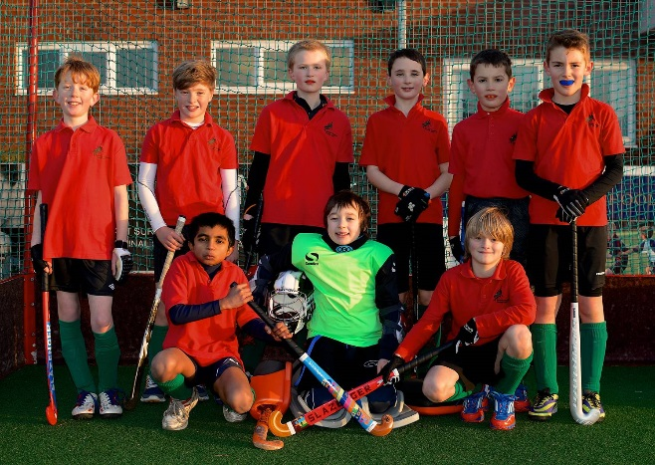
U10 Boys Red Dragons (Gold Tournament Team)
Manager: Crossy and Rob Panter
William Bowman
Ben Panter
James Cross
Edward Cross
Arjuna
Isaac Diver Hall (captain)
Alex Wolfe (GK)
Casper Lind
Cameron Tasker
We got off to a great start with a 1-0 win against Dereham which made us all feel more confident in front of goal. It was weird playing against our fellow team mates next, but we still managed to keep composure and won 4-0. A total of 9 goals in the next 2 games (Pelicans and NC Knights)- little did we know how important that tally would be at the end of the day. Two tough games to finish off; first up was Magpies where we only managed a 0-0 draw. Finally Norwich City, a decider for the tournament winners. Here we conceded our first goal of the afternoon and needed a goal to get back in the running. We pressed hard and got two short corners, one of which James hit a screamer in to the corner.
We came away with a gold medal each, having scored just one more goal than Norwich City. 15 goals scored and just one conceded; well done Dragons!
U12 Girls – Green Dragons (Gold Tournament Team)
Manager: Gemma Rump
Molly Finegan (GK)
Jodi Rump
Lara Taylor
Esme Potter
Aspen Gilvey
Alice Martin (Captain)
Meredith Winship
Alice Young
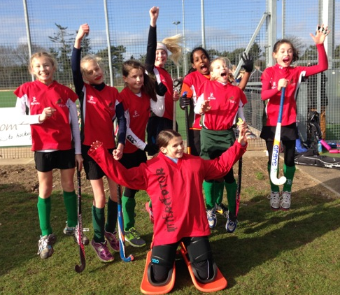
Dragons A did really well today despite coming in 5th overall. There are very good signs for great things to come as they settle into their positions during the season as they are already playing very well as a cohesive team.

Vs Norwich Eagles
Lost 1.0 ,
A good start from Dragons (against the team that ultimately won the gold league today) particularly from goalkeeper Molly who saved at least half a dozen shots at goal in short succession

Vs Pelicans
Lost 2-1
This could so easily have been 1-1 which would have been a fairer reflection of the way the match played out as it was very close and the team gelled well together with lots of great teamwork and passing. The first goal to Pelicans frustratingly trickled over the line. Jodi scored an excellent goal to level, but Pelicans again took the lead in the final minutes after a short corner was converted into their second goal. Great play by Dragons!

Vs Norwich Hawks
Draw 0-0
Dragons deserved to win this very closely fought match as they had a lot of possession of the ball, they just need to work on converting to goals now!

Vs Magpies
Lost 3-0
Magpies chose to up their game unfortunately when they played us, having not played to their usual standard up till that point. They scored three excellent goals despite some resilient defending and great teamplay by Dragons.

Vs Dereham
Draw 0-0
A very even game as the score shows, with a great attempt at a goal by Lara that could have so easily gone our way. Goalkeeper Molly saved the day when she bravely saved a goal flick.
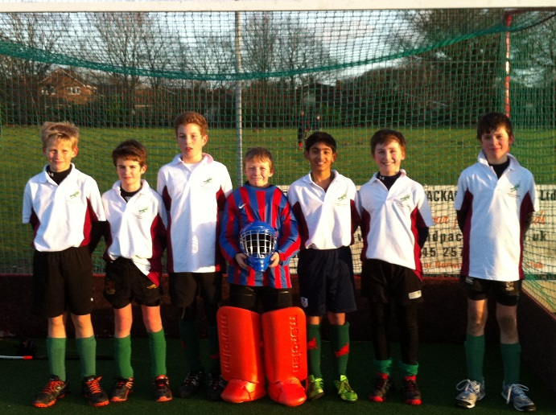
U12 Boys Green (Gold Tournament Team)
Manager: Natalie Beal and Ali Smyth
Angus RE (GK)
Jono CB
Daniel Murphy
Raunaq Rai (captain)
Ollie Shippam
Harry Williams
Edward Taylor
Tom Bailey
Huck Hempsall

It was a good day to play hockey the sun was out but bitterly cold due to the wind.

At this tournament we were the Gold Dragons in the gold tournament. We played lots of good hockey with our formation: 2-3-1. It was good exercise and everyone had fun. Problems started before our first game as Huck forgot his shin pads. But Ollie luckily had spares for some reason.

Lost 0-1
Our first game was against Magpies who had an excellent right winger who caused some trouble, but Tom B and Ollie handled him well. This was a close match, both teams had lots of chances but we couldn't get the ball past the 2 great keepers on both the teams. Their goal came near the end when their right winger dashed up, crossed it and they found the back-board. At the end of the match we were all feeling frustrated at some of the umpires decisions.

Won 2-1
Our second game was against Pelicans who all had strong hits, but we coped well and grabbed the ball before they had time to hit it. At the start, suddenly we found ourselves 1 down from a miss judged short corner. Pelicans were on top of us the whole game until the end. Our goal was a quick counter attack. Raunaq ran down the right with the ball, drew the keeper then passed to Harry with an open goal. 1-1. One minute to go. Tom Bailey did an outstanding pass to Edward who crossed it to Harry who got it through the keeper’s legs. 10 seconds later the whistle went. We had won!

Lost 1-3
Our third game was against the dreaded Norwich city. All their goals were an unstoppable undercut by their forward. Our goal was by Raunaq who skilled the keeper. 1-3 full time. In this game our defenders Huck and Tom did an outstanding job on stopping the attackers.

Won 2-1
Our fourth game was against Magpies again. Magpies were on us immediately with their quick right winger crossing it passed Angus and in the goal. We then seemed to wake up. Raunaq got the ball from Huck, did a quick 1 2 with Ollie and shot it into the corner. Our second goal was when Edward got the ball and did an amazing cross to Ollie who knocked it past the keeper.

Won 3-1
The game started excellently against Pelicans. Huck smashed it to Ollie who passed to Raunaq who placed it into the corner. The Pelican goal was at a short corner. They smacked it into the corner well out of the reach of Angus. We came back at them with Edward charging down the left with the ball, who again hit a great cross to Ollie who sent it flying through the keeper’s legs. Raunaq then scored by skilling the goalie.

Draw 1-1
Our last game was against Norwich city, and we were determined to improve from our last game against them. Huck and Tom stuck to their forward and hardly ever let him get the ball. Our first goal was the flukiest goal ever. Harry W got into the D and passed it to Ollie, who then tried to hit the ball first time but missed. The ball then rolled through the keeper’s legs and in the goal. Norwich’s goal came from their forward who got into a space and smashed it at Angus, who had no chance.

Our man of the tournament was won by Angus who showed some brilliant goal keeping skills and a great amount of hard work.

We came second and got silver medals, but were all disappointed because 1st and 2nd don’t get sweets!

Well done all!!
Report by Raunaq Rai

U10 Boys White (Silver Tournament Team)
Manager: Owain Diver Hall, Rob Panter and Natalie Beal
Henry Greenfield (GK)
Oliver Smith
Raphie C B
Freddie Royall
Harvey Nkrumah
Bertie Pinching
Sam Reynolds
Jake Reynolds (captain)
Oliver Hunt

There were only two ‘Silver Teams’ so these two teams had their own mini tournament, but also took part in the round robin of the gold tournament. They beat the other ‘Silver Team’ and therefore won that tournament. In the round robin, they came 5th out of 7. Well done boys! Thanks to Ben Nkrumah for his help on the sideline and thanks to Owain and Rob who took it in turns to manage this team so they could watch their sons in the other team.
U12 Boys Yellow (silver tournament team)
Manager: Spike
Ezra Kahn (GK)
Harry Brown
Leo Sargent
Blue Hempsall
Tom Linford
Harry Smith
Gus Sanders
Angus Blazer (captain)
Theo Wood

A good day for the Yellow team. Some great performances with Angus Blazer standing out in particular. Reports from the sideline say that on occasions the team had most of the possession, but were unable to score. Some things to build on as our own tournament approaches! Thanks to Spike for managing.

U12 Girls Pink (silver tournament team)
Manager: Robert Coyle
Harriet Marlee (Captain)
Charlotte Carr
Sofia Groves
Logan Gilvey
Lucy Buxton (GK)
Jennifer Cox-Kersley
Annabelle Hodgson
Yllandah Brown

The girls faced tough opposition but worked as hard as they could and did the club proud. Lots of potential there! Special mention to Lucy Buxton who volunteered to go in goal with no previous experience. The head of County Hockey in Norfolk was very impressed with Lucy’s performance! Well done Lucy! Thanks to Robert Coyle who managed a team for the first time.

